**Project Title: Premier Healthcare System**

Course: IS 603 Decision Support System

Dr. Kamran Fayyaz

Department of Information Systems

University of Maryland, Baltimore County

**Team B2:**

Poonam Gada

Kanika Danke

Sarthak Bhatt

Suraj Vartak

Prabhdeep Singh

**Premier Healthcare System**

**Table of Contents**

1. **Introduction to Premier Healthcare System**…………………………………………………………**3**

1. **Company Background3**
2. **A Single Version of the Truth4**
3. **Project Evaluation Process6**
4. **Define the Method & Model7**
5. **Business Solution & Layers10**
6. **Impacts/Results11**
7. **Lessons Learned12**
8. **Conclusions 12**
9. **References13**

INTRODUCTION

In 2010, The Patient Protection and Affordable Care Act (PPACA) was signed into law, marking the first time any major healthcare reform has taken place since Medicare and Medicaid were passed in the 1960’s.

With the passing of the PPACA, there came about many organizational changes. Every single man, woman, and child had enrolled in a health insurance plan or face a hefty penalty upon failure to do so. States could choose to either set up their own healthcare plan exchanges or use the federal government’s website. Insurance companies were required to cover pre-existing conditions as well as women's healthcare needs. In other words, a huge organizational, political, social, and economic change.

Of course, with big changes come big problems. Website security, availability, and data storage became hotbed issues due to significant downtimes, reports of data leaks including Social Security numbers, as well as the inability of hospitals and insurers to coordinate and streamline patient details and data. To solve this problem, several companies were contracted, with Premier Inc. being one of them.

# COMPANY BACKGROUND

Premier Inc is a healthcare improvement organization joining a collusion of roughly 3,750 U.S. clinics and more than 130,000 other supplier associations. As an industry pioneer, Premier has made a standout amongst the most far reaching databases of noteworthy information, clinical prescribed procedures and effectiveness change methodologies.

Their award winning and progressive advancements empower their members to work together more effortlessly and productively. They will probably enhance their members quality results, while securely diminishing expenses. By connecting with members and uncovering new open doors, they engage the cooperation to enhance the execution of medicinal services associations.

Named one of the World's Most Moral Organizations 9 years in succession, they are all around prepared to change the fate of health care.

# A SINGLE VERSION OF THE TRUTH

# The world healthcare IT market is expected to grow from US$99.6 billion in 2010 to $162.2 billion in 2015. Healthcare spending reflects the standard of living in a developing country, high- quality medical treatments, advanced technologies which create possibilities for curing diseases. The main aim of IT in health care system is to reduce healthcare unnecessary costs, improve the quality in medical and healthcare organizations, and fulfill the huge demand for efficient and error-free healthcare delivery. Doctors, hospitals, insurance companies, and pharmacies are finding a way to understand more efficiently their business needs so that they can identify opportunities to reduce costs and improve quality.

# 

# Premier healthcare system tie up with so many different U.S. hospitals situated at different locations and other healthcare websites, there is infinite data in healthcare about every patient, condition, procedure, and drug across multiple providers and organizations. Few challenges they were facing like,

# 

# 1)The ability to access, manage, connect, and understand these large set of data to create actionable insights is critical and complex too.

# 

# 2)Delivering data through a large extensive healthcare framework is a challenging process. Also with a large set of information Premier also had to confirm that it can segregate each & every small healthcare organization’s information to keep on meeting patient privacy requirements and prevent unauthorized access to sensitive information.

# 

# 3)Needs to guarantee the data quality while keeping the protection and security of the historic high level of data. High quality is must, even a solitary small mistake during detecting, sensing, controlling or monitoring procedures could lead to a serious genuine consequence.

# 

# According to the study every year, patients worldwide require longer hospital stays because of medical and medication-related errors and blunders, resulting in total 2.4 million extra hospital days. Sometimes such errors also result in 32,000 deaths and $9 billion in expenses yearly

# 

# Here Premier mission is simple: How to improve the health of communities and how to help its members to improve the quality of the care they provide and minimizing the costs?

# 

# To overcome this problem, Premier introduced few models of care delivery which could improve the quality of care and settlement to assist their members. But here Premier faced the challenge as company’s existing technical infrastructure includes hardware and software could not support these new models. Following a couple of years, Premier had built up a series of “siloed” applications. It’s an application that does not connect or interact with different applications or frameworks. It is the software that functions in its own manner to take care of a problem. It regularly found within a department having large enterprises. Be that as it may, there were a few issues with "siloed" application,

# 

# Two major problems with “siloed application” were,

# 

# 1) IT systems that cannot communicate with one another if data elements stored in incompatible formats. It shows as “a lack of interoperability.” Different databases and software systems hold different sets of data, it's difficult to get a complete picture of a patient’s health, so accurate analysis of all information was tough to do.

# Ex: If one of the hospitals has data in excel sheets i.e. CSV format and other is using some advanced technologies so has their data in JavaScript, i.e.Json format. So here Premier need to have a framework that converts data into the unique identifier.

# 

# 2) Issue with integrating different huge data sources from where the data is coming and see the “big picture” of how to determine healthcare transformation.

# 

# So, to overcome these problems Premier started putting effort to enable sharing and analysis of a large amount of data from its thousands of members and different sources. It started looking for the new data infrastructure and architecture uses flexible infrastructure having flexible software and hardware to deliver reliable, scalable information in the right format at the right time in front of users based on their roles.

**Flow Chart:**

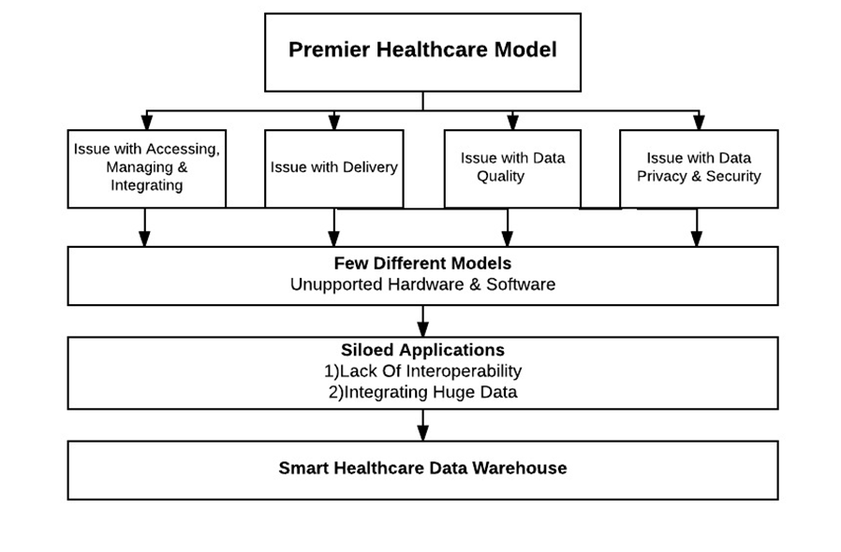

# PROJECT EVALUATION PROCESS

# To implement a project in an organization, it is very important that all the departments are in sync and they give the approval for it along with allocating resources. There should be standards for pre-evaluation and post project implementation of a project.

# 

# During project evaluation process, a project must be evaluated financially and qualitatively along with the associated risks during the phase of its implementation and after it is implemented as well. In the case of Premier Healthcare Alliance, it was very important how much the project will cost billions to implement a smart healthcare framework and how many lives of people would be saved.

# 

# The Project Evaluation process helps us in finding out the scope and the requirements of various departments within Premier Inc organization. Following are the listed Departments which need to be reviewed for project evaluation process:

# 1) IT Department: Initially siloed applications were used, after implementing the collaboration with IBM, the organization would need a healthcare framework which would collaborate all the data from the various healthcare sites and incorporate it into one single data warehouse. For Example, Same drug stored in the various databases of different healthcare institutes should be having one single name after all the databases are integrated. To achieve this, the organization should implement unique data identification(UDI) and Global Data Synchronization (GDSN) for smooth processing of data so that the same drug having different names in the databases be identified by one single name. Also, the organization needed a system which could be faster as the data grows in the coming years ensuring scalability along with the ability to connect to the information hub remotely in a secure manner for its members.

# 

# 2) Finance Department: To implement the project on such a large scale it would require investing millions of dollars over a period of years. The finance department would need estimates for installing the various hardware suggested by IBM so that the healthcare framework could run on them. Having collaboration with a partner organization if any would involve additional funding in case the partner is going through financial constraints. Also, the various software to be implemented for bringing together the healthcare sites and its information should be accounted for while preparing the cost estimates. This department would need to compile the data of the patients and their insurers regarding Insurance policy renewals and the existing policy claims, terms and conditions. This also falls under the purview of the legal department concurrently.

# 

# 3) Legal Department: This department of Premier Inc would need to have permission from the existing members for the use of their data in their data warehouses to get their data onto a common platform. Also, information Exchange amongst various hospitals regarding their patient history and treatments would need a legal framework of how that could be taken care off along with the consent of its customers or patients.

# 

# 4) Human Resource Department: This department would need an estimate of man-hours that would be needed to allocate to the project with its collaboration with IBM. Also, they would need an estimate of the number of professional that would be needed to train so that transfer of knowledge happens to its employees when the new system is up and running.

# 

# 5) CRM Department: This department would need new practices and techniques that would help it to analyze the interactions of all the members of Premier Inc especially from patients to physicians and drug manufacturers so that all this data could be integrated into the new Healthcare Framework along with ensuring scalability of the data as the organization grew.

# 

# Apart from the needs of various departments within Premier Inc the management would also have to evaluate various risks related to the implementation of the project.

# The following would be the risk factors that would have to be taken care of while the project is being implemented:

# 

# 1) Corporate Environment: Since the above project is a collaboration between two big organizations namely IBM and Premier Inc difference in the corporate environments and viewpoints amongst the workforce could create a difference of opinion in work environment.

# 

# 2) Ownership: Having a clear ownership of plan guarantees success in a project. There could have been unclear outlining of responsibilities and conflict of interest between the executives of IBM and Premier Inc while implementing the project which might have delayed the project.

# 

# 3) Relationship Management: Managing relationships is an important factor while evaluation and executing a project. Lack of involvement from hospitals and various healthcare sites to integrate the data into a single platform could have posed a risk for IBM and Premier Inc.

# 

# 4) Project Management & Planning: Integrating data from 2600 hospitals and 84000 healthcare sites involves great risks in terms of project planning and allocating resources for the smooth transition of the network from siloed application to a smart healthcare framework.

# 

# 5) Technological Risks: IBM Relying on various software tools for the smooth functioning of the healthcare framework posed risks as lack of interoperability between its tools could render the whole healthcare framework unusable.

**DEFINE THE METHOD AND MODEL**

With Premier Inc having a network of 2600 hospitals and 86000 healthcare sites it had so much of data and information that data was its most strategic asset. It was important for Premier Inc to have the data available to its users from remote places and considering it was growing at a faster rate. It had to develop a model which would provide data sharing and insights and develop tools that would analyze the data.

To have a system which empowers data sharing, remote access, data analytics and ensures scalability at the same time Premier Inc had to go through the following 5 steps:

**1) Defining the Data Sources:** For an organization like Premier Inc it had a huge amount of structured and unstructured data coming from clinical, operations, financial systems social media and public health records. To define data sources, Premier Inc started compiling a list of future and current data sources to identify possible options. It involved analysis of whether compiling two or more data sources would give more insights than if they were separate and how the underrepresented data would be augmented with new sources.

**2) Enhancing the Quality of sources and Setting the data Quality Metrics:** As the name implies Premier Inc assessed data quality levels of all its sources along with corrective actions so that data quality was maintained on a uniform level across all the sources and improvements were undertaken. After that data was normalized to standard formats and structure so that a common healthcare model would be implemented consisting of all the sites to carry out analytics.

**3) Integration of data sources:** After understanding how to analyze and use different data sources IBM in collaboration with Premier Inc set a common platform to integrate the data. This platform was decided based on the quality of data whether structured or unstructured, the availability of data to its users and how it was to be analyzed by the user who could be a drug manufacturer a physician or even patient.

**4) Identifying Analytic needs: Since** Premier Inc was in the healthcare domain it had different requirements and it needed different visualization and statistics as its priorities were different. Analytics where needed for basic reporting of current data like identifying the trend of a patient’s medical illnesses and predicting his future needs for care. However, reports for a patient’s history needed different data sources whereas predicting his health and expenses in the future needed different data sources. All this had to be taken into consideration while defining the analytic tools.

**5) Securing and Managing the Data Lifecycle:** Premier Inc had to maintain the security of its data source, the Installed hardware and software of IBM and the clinical, financial and operational information of the healthcare institutes. At the launch of the collaborative project between IBM and Premier Inc, the data lifecycle was established for retention, reuse and auditing of current and past data. To gain trust from its members, data lifecycle for the project included the understanding of data evolvement for the coming years and how its quality would be enhanced by integrating all the data sources together from the hospitals and healthcare Sites.

To have fast, scalable, secure and a large network to carry out data analytics for its members our group chalked out a Smart Healthcare Model which would be implemented for Premier Inc,

**SMART HEALTHCARE DATA WAREHOUSE MODEL**

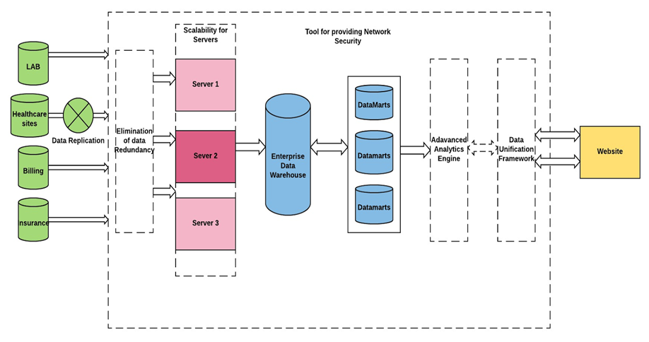

**DEFINE TECHNIQUE AND TOOLS**

**Network security:** Keeping in mind, the expansion and existing infrastructure of premier, non-centralization, scalability and power are some of the factors which should be addressed when building the network security layer for it.

Premier was known to use the conventional RR model pattern for securing its network and to integrate it with the new expanded model designed for data warehousing, RR could be the weakest network patter to accommodate in the new designed model because of its limitations of not addressing the problem of scalability. In our new model, we found Peer to Peer(P2P) based network model best suitable for construction of security layer which was easy to integrate with the load balancer between the servers and was reliable in term of data exchange between the server. P2P services provide strong and scalable trade obedience for sharing the files internally between the servers and with the customers. The data that is shared is in the form of distributed has table patterns such as Pastry, Tapestry which keeps the data encrypted and working smoothly with load rotation between the network nodes per server’s ability to handle the load.

NARSES will be used to power the P2P network security as it will be responsible to simulate the flow based network. Benefit of using Narses is to simulate the aggregated flows rather than processing single information packets and will ultimately result in reducing the number of memory requirements and the load balancer must do less work in allocation of memory as the whole packet will be processed in the form of single event. Also, analyzing the bandwidth feature of Narses, we found that it assumes the bandwidth available for the first link and set it for others remaining. It has the record of transmitting 222 kb flow of data for a model which consisted of 600 nodes.

**Data Reduction Tool:** The data reduction tool will serve as the filter of entrance in our data model. It is Data deduplication or “Single instance storage” which helps in pacifying the need of extra storage by eliminating duplicate data. It is also compatible with the P2P network model which only stores a unique occurrence of data in the server and hence it saves lots of space on it. This process of lowering disk space will eventually lead to saving of financial resources on the Data redundancy process

It has been installed on the block level and highly efficient than any other file deduplication tools. The method of working in block level deduplication is basically its lookup feature is concerned with the content of the file instead of treating the file has a whole instance. The data at this level is processed by MD5 or SHA-1 algorithms which assigns a unique hash number for each instance, as only the changed data will be saved without remaking an entire new file, if the file has been updated.

**Load balancer:** Application Delivery Controllers will be used to power the load balancer. A combination of OSI layer 2/3/4 based on routing technique will handle the process of load balancing.

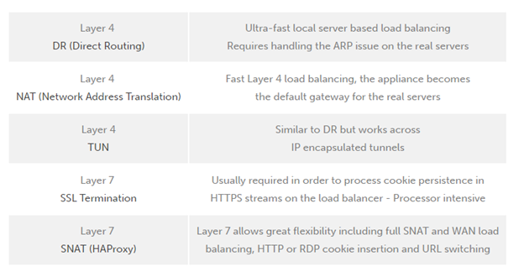

**BUSINESS SOLUTIONS AND LAYERS**

Evaluating every aspect of data warehouse model, it comes to the need of figuring out business solutions which will bring the real-time business intelligence in premiere healthcare. The top most requirement was to come up with a solution which will bridge the gap between mainframe and the web. Following are the different business solutions that must be implemented on the well-developed data warehouse model addressing all the problems.

* Leveraging the infrastructure for mainframe or making some investments in legacy can serve as the shortest path to bridge the gap.
* It must be implemented in a way that there should be an optimum utilization of the existing hardware and the well-trained manpower in the company.
* It should be set up in a manner that all the web-enabled environments get an add-on security.
* As it will soon become a real-time business intelligence, it must possess a powerful platform for development.
* Not the least, it must have the ability adapt to changing business needs in no time.
* Well established a connection will be the priority requirement from the mainframe-based web server to the host data and applications.

**Solution Tier:**

**Economy and Efficiency:** Initially the expenses may sound too high for setting up the intranets, but rather than going for some cheap departmental solutions which soon requires integration with other systems tends to cost more. The desired solution should be one of the best long- term investment that company should make. It should be able to reduce the central processing cost of existing applications which will finally lead to a huge amount of economic saving. It should be designed in with so much flexibility that makes it usable with multiple mainframe web servers and easy to migrate between them without redesigning other applications.

**Scalability:** The installation and maintenance process should be as simple as possible and it must not use more than one software for the single platform, even though there would be different ways to use it. Configuration shall be done without the sacrifice in scalability or power.

**Security:** Although mainframe designing comes with an inherent advantage of the unparalleled security, still there are ways breach the mainframe without compromising the well-developed firewall protecting it. To protect mainframe from such kind of threat, it should have the provision of isolating back-end with the web-portal with a two-layer network protection which gives the system an additional level of security.

**THE IMPACT / RESULTs**

**1) New model helps to solve complex problems with complex data**

• Premier can now solve complex problems by building reliable, accurate and up to date information to support your business and clinical requirements.

• It helps healthcare organizations to provide their staff with accurate and proper information to support the evidence-based delivery, patient-centric care.

**2) Turn insights into action**

• It helps to integrate most valuable data across the organization to gain insight into operations.

• Integrate clinically and financial data to support emerging care delivery models and improve business visions.

• Integrate genomic information with patient clinical data records to help design and track population health screenings.

**3) Smart Healthcare Data Warehouse Model reaches far beyond simple data gathering.**

• The new software could track improvements and trends in cost and quality over time with historical views and traceability.

• Enable detailed analysis by using different business analytics applications.

• Combine resource and clinical information to identify areas of waste and inefficiency that may result from increasing the cost of care delivery.

• Expand dashboards and reports to include emerging clinical areas without re-implementing an entire platform.

Smart Healthcare Data Warehouse Model offers a significant advantage through the ability to continuously process data, from patient information to medical care utilization, and transform it into information led business initiatives. It tries to unlock information contained in individual applications and repositories from a variety of vendors and making it readily available to the people and process when need it. It can help get you closer to a true information management infrastructure.

**LESSONS LEARNED**

Premier healthcare services required a new architecture and infrastructure that could help them to take care of the issue of siloed applications that were created throughout the years, making it troublesome for members to associate diverse information sources and measurements. Premier's prior stages and related programming frameworks likewise did not have the adaptability required to bolster the gigantic exchange volumes that were required.

Premier needed to guarantee that information protection and security was kept up and to forestall unapproved access to sensitive data. Premier needed to replace its current x86 servers to accomplish more noteworthy execution easily at affordable rate.

The new framework Premier executed utilized IBM software and hardware to convey trusted data in the right setting at the correct time to clients based upon their parts. With help from IBM and IBM Premier Business Partner, Perficient, Inc., the Premier healthcare built up a totally new IT procedure, utilizing a Software As A Service (SaaS) model in light of the IBM Health Integration Framework.

Premier moved its center information stockroom to IBM DB2® pureScale, which is profoundly adaptable to bolster the developing measure of information that Premier was gathering from its members. IBM InfoSphere® software was now used to procure, change and make a solitary, trusted perspective of every constituent or substance which tackled the issue of siloed applications.

IBM Tivoli® software was utilized as a part of the recently executed framework to understand the issues of protection and security. Premier directed its Application development upon Rational® software and a typical client experience and coordinated effort were given through IBM Connections software in the new framework.

IBM Netezza® data warehouse appliance was actualized in the new architecture to empower its members to lead progressed examination quicker and less demanding than was already conceivable. IBM Cognos® Business Intelligence was utilized to help members distinguish and examine opportunities and patterns over their associations.

Premier likewise supplanted its current x86 servers with IBM POWER7® processor-based systems to increase more prominent execution at a lower cost which brought about up to a 50 percent expansion in processing power with a decrease in expenses.

**CONCLUSION**

Premier Inc. needed a way to implement their new models. The current infrastructure was created with the mindset of having multiple siloed applications, applications which do not interact with other systems and go about their own assigned tasks and usage. While this system was sufficient in the previous years, the new age of data sharing has rendered such a framework inefficient, bulky, and expensive to maintain.

To solve their conundrum, Premier Inc. teamed up with IBM to implement a Smart Healthcare Data Warehouse Model, a model which allows them to examine data from the thousands of healthcare providers, create new practices to better reach patients, and share research and innovations with regards to patient treatment and overall care.

In conclusion, by partnering with IBM and implementing this approach, Premier Inc. has once again launched to the forefront of data sharing within the healthcare IT industry by modernizing their approach, increasing patient outreach, and expanding processing power while decreasing expenses.

**REFERENCE**

* **http://www.ibmbigdatahub.com/sites/default/files/document/IMC14754USEN.PDF**
* [**http://www-01.ibm.com/common/ssi/cgi-bin/ssialias?htmlfid=IMC14754USEN**](http://www-01.ibm.com/common/ssi/cgi-bin/ssialias?htmlfid=IMC14754USEN)
* [**ftp://public.dhe.ibm.com/software/data/sw-library/industry-models/brochures/IBM_health_care_provider_GIMv85.pdf**](ftp://public.dhe.ibm.com/software/data/sw-library/industry-models/brochures/IBM_health_care_provider_GIMv85.pdf)
* [**https://www.premierinc.com/about-premier/**](https://www.premierinc.com/about-premier/)
* [**http://ieeexplore.ieee.org/stamp/stamp.jsp?arnumber=6515977**](http://ieeexplore.ieee.org/stamp/stamp.jsp?arnumber=6515977)
* [**https://www.sec.gov/Archives/edgar/data/1577916/000157791615000009/pinc-2015630x10k.htm#sE3DE8BAE26D453EF9FB52EAE171E257B**](https://www.sec.gov/Archives/edgar/data/1577916/000157791615000009/pinc-2015630x10k.htm#sE3DE8BAE26D453EF9FB52EAE171E257B)
* [**https://www.sec.gov/Archives/edgar/data/1577916/000104746913008658/a2216415zs-1.htm#dq13301_selected_consolidated_financial_and_other_data**](https://www.sec.gov/Archives/edgar/data/1577916/000104746913008658/a2216415zs-1.htm#dq13301_selected_consolidated_financial_and_other_data)
* [**https://www.computer.org/csdl/proceedings/hicss/2006/2507/09/250790216c.pdf**](https://www.computer.org/csdl/proceedings/hicss/2006/2507/09/250790216c.pdf)
* [**https://www.computer.org/csdl/proceedings/hicss/2010/3869/00/04-08-01.pdf**](https://www.computer.org/csdl/proceedings/hicss/2010/3869/00/04-08-01.pdf)
* [**http://www.mcpressonline.com/software-news/business-intelligence/ibm-partner-premier-healthcare-alliance-helps-members-save-nearly-$14-billion.html**](http://www.mcpressonline.com/software-news/business-intelligence/ibm-partner-premier-healthcare-alliance-helps-members-save-nearly-$14-billion.html)
* [**http://www.bwdb2ug.org/PDF/pureScale_bwdb2ug_Final.pdf**](http://www.bwdb2ug.org/PDF/pureScale_bwdb2ug_Final.pdf)
* [**http://www.ibm.com/support/knowledgecenter/SSTFXA_6.2.0/com.ibm.itm.doc/itm_install07.htm**](http://www.ibm.com/support/knowledgecenter/SSTFXA_6.2.0/com.ibm.itm.doc/itm_install07.htm)
* [**http://nesystems.com/solutions/industry/healthcare/**](http://nesystems.com/solutions/industry/healthcare/)
* [**http://www.ibm.com/support/knowledgecenter/SSZJPZ_9.1.0/com.ibm.swg.im.iis.productization.iisinfsv.overview.doc/topics/cisoarchoverview.html**](http://www.ibm.com/support/knowledgecenter/SSZJPZ_9.1.0/com.ibm.swg.im.iis.productization.iisinfsv.overview.doc/topics/cisoarchoverview.html)